Guide to Using IntelliWriter®
IntelliWriter® is helpful at all stages of the writing process and for all types of writing. Below are some tips for using the application and documents within its Writer's Guide to help you in your <Insert Course Name Here> course.
Evaluate your draft by writing domain.  After saving a document and using the "Check My Doc" button, use recommendations to improve your draft's effectiveness in four writing domains: focus/purpose, content/development, organization, and style. Colored dials in the stats section (yellow and green in the example to the right) tell you how your draft aligns with expectations. | 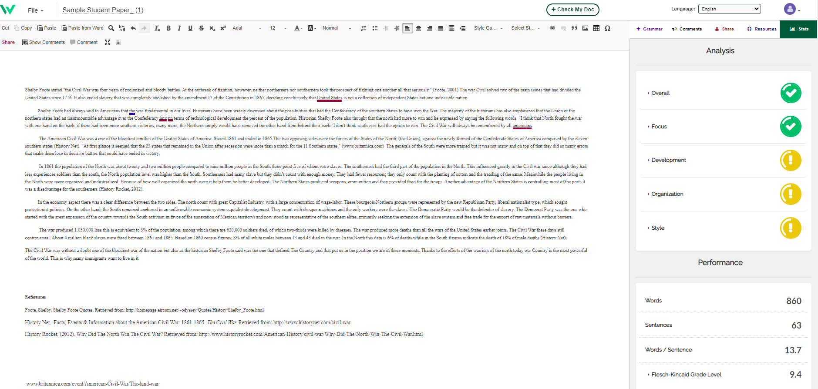
Identify areas for improvement.  The "Grammar" button (purple in the image) may contain suggestions, such as to avoid cliches or contractions. | 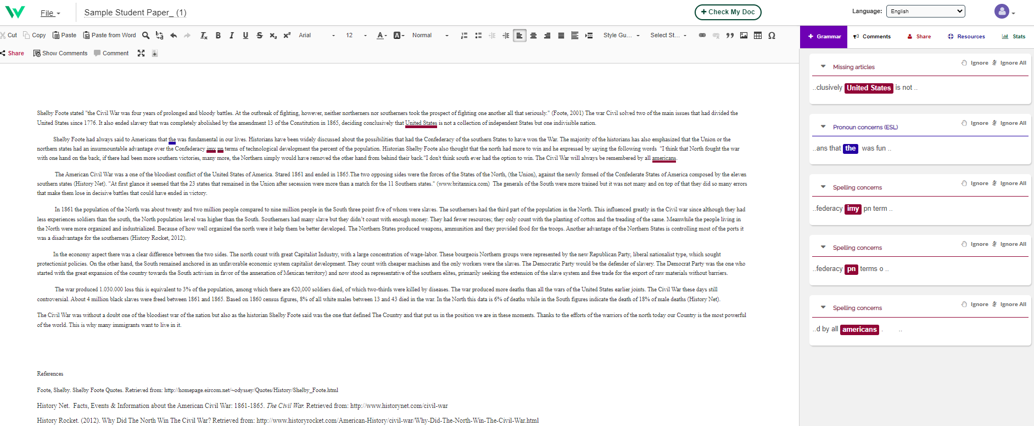
Access writing help.  As shown in the image, use the Resources tab (blue in image) to reach the Writer's Guides. | 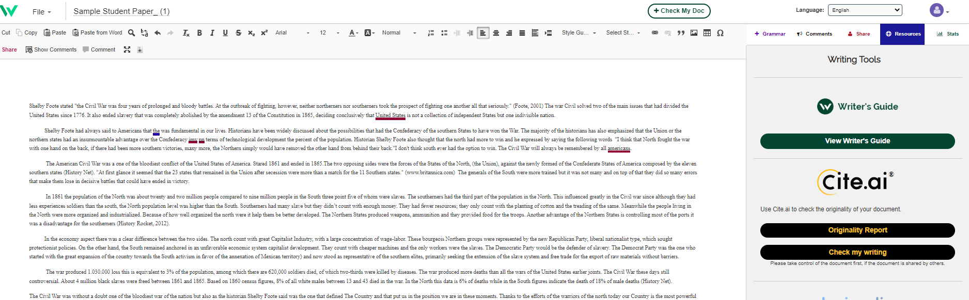
Locate a specific help resource.  Typing a keyword into the Writer's Guide search window will produce a list of possible resources that you can use to help you with the specific area of concern that IntelliWriter® has identified. | 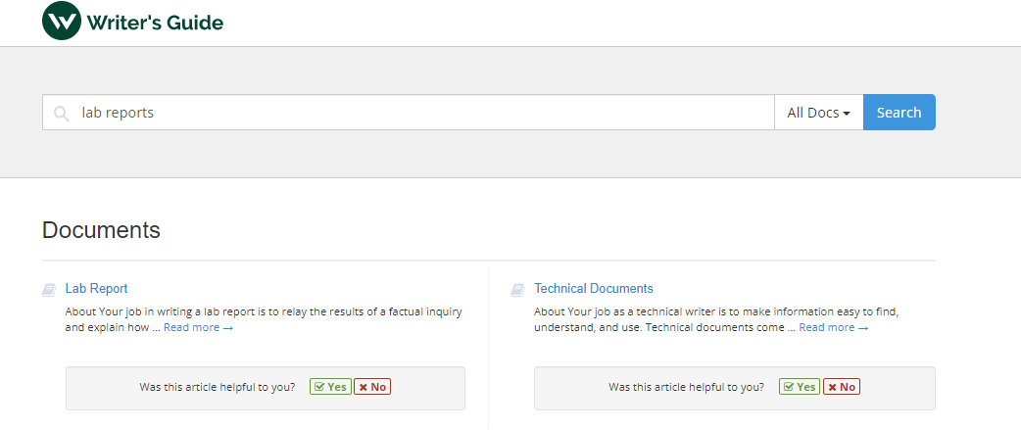
Check for originality.  The process of weaving others' ideas into one's own is challenging, not to mention a critical step on the path to higher levels of education. Use the Cite.ai button to scour the Web and alert you to text that should be cited. IntelliWriter will then provide you with a detailed Originality Report. | 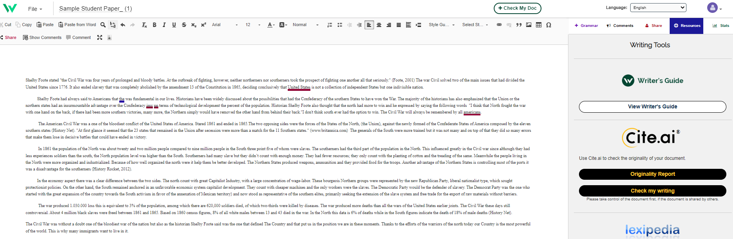
Additional Resources
Step-by-Step Writing Process: https://guide.writeahead.com/docs/general-writing-2/step-by-step-writing-process/
Essays: Getting Started: https://guide.writeahead.com/docs/general-writing/essays-getting-started/ Paragraphs: Structure: https://guide.writeahead.com/docs/general-writing-2/paragraphs-structure/

Help and Support: https://resource.vantage.com/display/IW/IntelliWriter+-+User+Guide

